Answer the following questions:-

1.**Insert a new employee named "Alice Johnson" with an EmployeeID of 3:**

| INSERT INTO Employee (EmployeeID, EmployeeName)  VALUES (3, 'Alice Johnson'); |
| --- |

1. **Insert a new assignment with Assignment_ID of 3, assigning date '2024-07-23', for the 'HR' department and the 'Project Alpha' project:**

| INSERT INTO Assignment (Assignment_ID, assigning_date, Department_ID, Project_Id)  VALUES (3, '2024-07-23', (SELECT Department_ID FROM Department WHERE Department_Name = 'HR'),  (SELECT ProjectId FROM Project WHERE ProjectName = 'Project Alpha')); |
| --- |

1. **Add a new column Email of type VARCHAR(100) to the Employee table:**

| ALTER TABLE Employee  ADD Email VARCHAR(100); |
| --- |

1. **Change the data type of the Department_Name column in the Department table from VARCHAR(225) to VARCHAR(255):**

| ALTER TABLE Department  MODIFY COLUMN Department_Name VARCHAR(255); |
| --- |

1. **Increase the salary of all employees who work in the 'IT' department by 10%:**

| ALTER TABLE Employee  ADD Salary DECIMAL(10, 2);  UPDATE Employee  SET Salary = Salary * 1.10  WHERE EmployeeID IN (  SELECT EmployeeID  FROM Department  WHERE Department_Name = 'IT'  );      Answer For Dataset 2:- |
| --- |

Question 2: Given the following table employees with columns id, name, department, salary, and hire_date, write a query to retrieve all employees who are either in the 'Sales'

| SELECT * FROM employees WHERE (department = 'Sales' AND salary > 50000)  OR (department = 'HR' AND hire_date > '2020-01-01'); |
| --- |

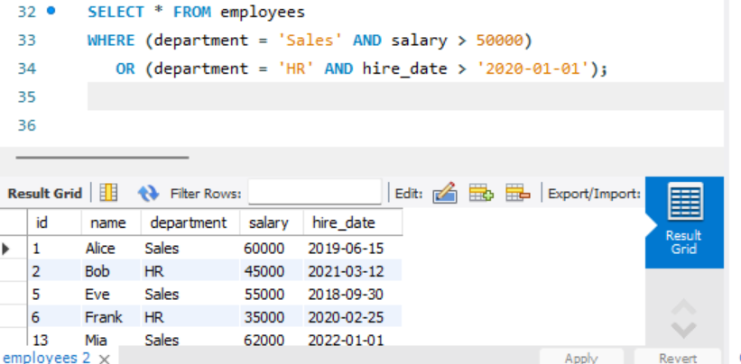

Question 3: What is the output of the following query?

| SELECT name, salary FROM employees WHERE salary > 50000 AND (department = 'Sales' OR department = 'HR') ORDER BY department DESC, salary ASC; |
| --- |

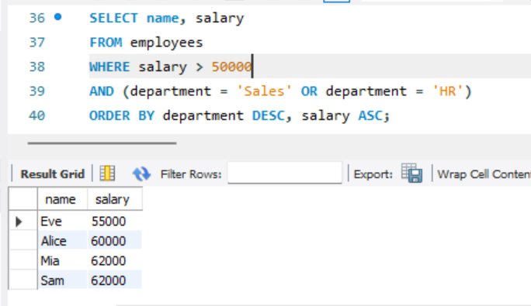

Question 4: Write a query to retrieve all employees with salaries between 40000 and 60000, excluding those in the 'Marketing' department, and order the result by hire_date descending and salary ascending.

| SELECT * FROM employees WHERE salary BETWEEN 40000 AND 60000  AND department <> 'Marketing' ORDER BY hire_date DESC, salary ASC; |
| --- |

Question 5: Write a query to find employees who are either not in the 'Finance' department or

have a salary less than 30000, and then order the results first by department in ascending

order and then by name in descending order.

| SELECT * FROM employees WHERE department <> 'Finance' OR salary < 30000 ORDER BY department ASC, name DESC; |
| --- |

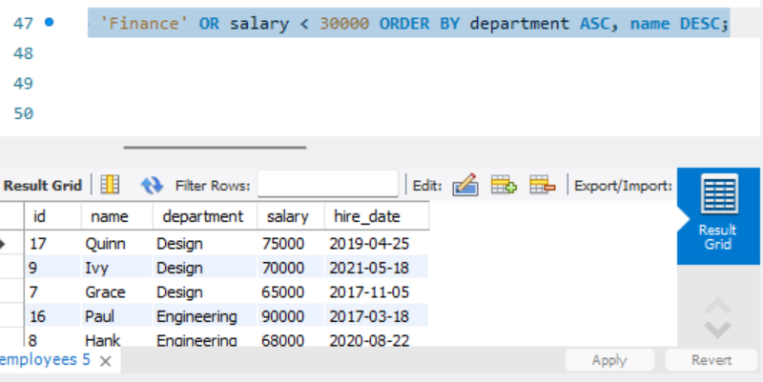

Question 6: Write a query to retrieve employees whose name starts with 'A', have been hired after January 1, 2015, and order the results by their name in ascending order.

| SELECT * FROM employees WHERE name LIKE 'A%' AND hire_date > '2015-01-01' ORDER BY name ASC; |
| --- |

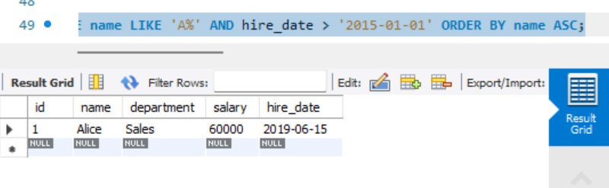

Question 7: Write a query to find employees who are in either the 'Engineering' department with a salary less than 70000 or the 'Design' department with a salary greater than 60000, and order the results by salary descending.

| SELECT * FROM employees WHERE (department = 'Engineering' AND salary < 70000) OR (department = 'Design' AND salary > 60000) ORDER BY salary DESC; |
| --- |

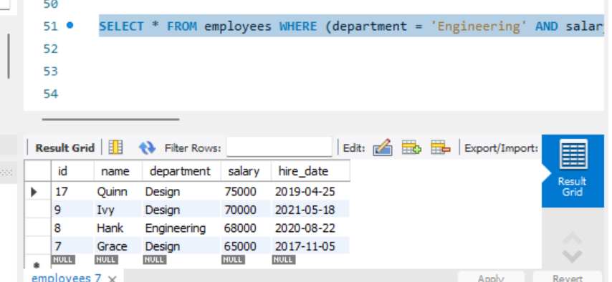

Question 8: What will be the result of the following query if the employees table has columns name, salary, and hire_date?

SELECT name, salary, hire_date FROM employees;

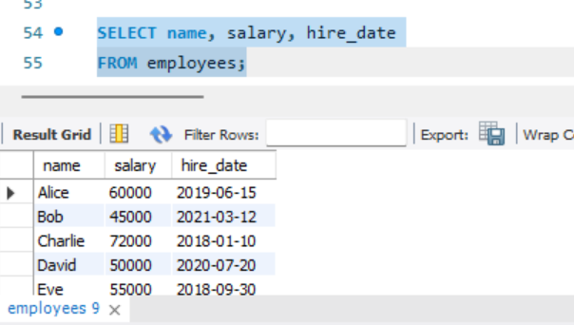

Question 9: Given the following table projects with columns project_id, project_name, start_date, and end_date, write a query to retrieve all projects that started before January 1, 2022, or ended after December 31, 2022, and order the result by project_name in descending order.

SELECT * FROM project

WHERE start_date < '2022-01-01'

OR end_date > '2022-12-31'

ORDER BY project_name DESC;

Question 10: Write a query to find employees with a name ending with 'son', not in the 'IT' department, and order the results first by salary in descending order and then by hire_date in ascending order.

| SELECT * FROM employees WHERE name LIKE '%son'  AND department <> 'IT' ORDER BY salary DESC, hire_date ASC; |
| --- |

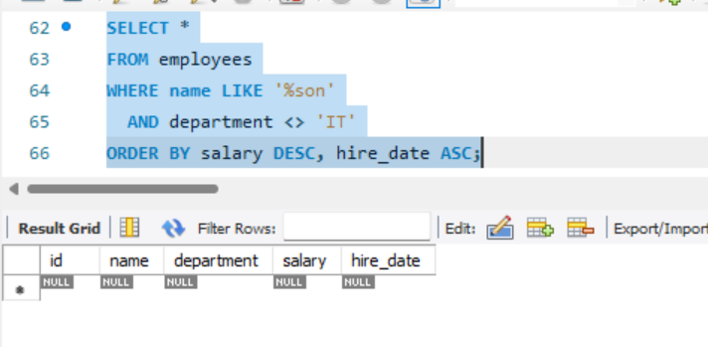

Question 11: Write a query to retrieve employees who were hired in the year 2021 and have a salary greater than the average salary of all employees, and order the results by name in ascending order.

SELECT * FROM employees

WHERE YEAR(hire_date) = 2021

AND salary > (SELECT AVG(salary) FROM employees)

ORDER BY name ASC;

